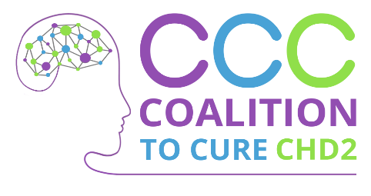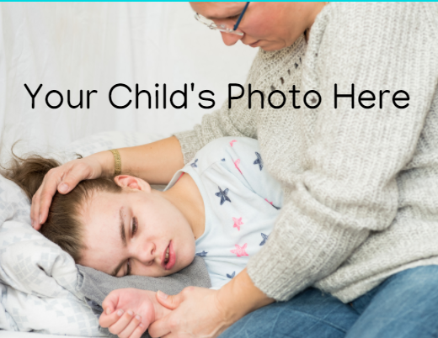

(Insert Date)

Dear (Family/Friend’s name),

(Last year/last month/etc.) (your child’s name) was diagnosed with a genetic mutation on (his/her) CHD2 gene, which causes (your child’s symptoms: Seizures, Autism, severe developmental delays, etc.) (His/Her) disease is so rare that there are only approximately 200 people reported around the world with this disease.

In the world of rare diseases, patient advocacy groups play a key role in supporting families and connecting researchers to a disease. Our family is lucky to have the Coalition to Cure CHD2 promoting our needs and priorities.

CCC is a volunteer, parent-led non-profit dedicated to aggressively funding medical research to find targeted treatment options and a cure for those with CHD2 variants.

One of the CCC’s first initiatives was to establish a data collection repository for every CHD2 patient in the world. They have already enrolled over a hundred of their patients! www.curechd2.org/rare-x-numbers. This database will allow doctors and scientists to collect and share information about patients with CHD2 gene variants. This first step is vital as patient data will be used to attract funding from pharmaceutical and biotechnology companies as well as from the NIH (National Institute for Health). They have spoken with close to 20 different scientists and researchers across the globe who have interest in studying CHD2 further. They also are in the process of raising enough funds to create a grant program which provides seed money to academic scientists for clinical studies related to the development of potential new treatments for CHD2.

This research is costly. With your help, they will be able to fund life-changing research studies.

DONATE AND LEARN MORE ABOUT THEIR ORGANIZATION, WWW.CURECHD2.ORG AND DONATE TODAY: WWW.CURECHD2.ORG/DONATE

Thank you from the bottom of our hearts.

Sincerely,
(Your Family’s Name)

Coalition to Cure CHD2’s Federal Tax ID is: 85-4057370

